Grading Guidelines:

A right answer will get full credit when:

1. It is right (worth 25%)
2. It is right **AND** neatly presented making it easy and pleasant to read. (worth an **extra** 15%)
3. There is an **obvious and clear link** between 1) the information provided in the exercise and in class and 2) the final answer. A clear link is built by properly writing, justifying, and documenting an answer (worth an **extra** 60%).
4. Calculation mistakes will be minimally penalized (2 to 5% of full credit) while errors on units will be more heavily penalized.

**Late Submission** : as specified in the syllabus. Days counting starts one minute after the deadline.

**Check Your Submission:**  after submitting, download your submission to check whether it is the right version and it is complete.

You are welcome/encouraged to discuss exercises with other students or the instructor. But, ultimately, **personal** writing is expected.

* USE THIS FILE AS THE STARTING DOCUMENT YOU WILL TURN IN. **KEEP IN THE QUESTIONS** AND INSERT YOUR ANSWERS.
* IF USING HAND WRITING (STRONGLY DISCOURAGED), REWRITE THE QUESTIONS.
* FAILING TO FOLLOW TURN IN DIRECTIONS /GUIDELINES WILL COST A 30% PENALTY.

Objectives of this assignment:

* to learn independently about an important topic
* to answer questions about the independently studied topic
* to empower you: you can learn any networking topic on your own
* to learn independently new concepts

What you need to do:

Answer the questions and/or solve the exercises described below.

Objective: The objective of this assignment is to learn independently about *Network Address Translation (NAT)*. You must research and read about NAT, and then answer the questions.

Resources:

1. **Textbook:** Tanenbaum, Andrew S. and David J. Wetherall. *Computer Networks*.
2. Module 5
3. Your instructor (Through Piazza)
4. RFC 3022
5. Internet

**Answers and key arguments/justifications are expected to reflect the textbook.** Textbook related material and your instructor are sufficient to answer all questions in this homework.

**Questions**: (**hint**: read first all questions before answering. This will avoid you repeating or overlapping answers).

**Generalities**

1. **(5 points)** Which problem does NAT address or solve? (Answer must be consistent with the textbook)

The problem that NAT looks to solve is that of the limited IPv4 addresses. Any addressing scheme is going to have a finite number of usable addresses. As the book says as the internet grew the pool of IPv4 addresses was insufficient to accommodate every device with a unique global address. With NAT this can allow a number of different devices to use one global address to share. This conserved a good percentage of the addresses overall.

1. **(15 points)** Explain briefly what NAT is (about 5 to 10 lines). Refer to **Figure 5-55** below to illustrate your explanations. (Answer must be consistent with the textbook)

NAT stands for Network Address Translation. This is used to map multiple private addresses to one public address that is then used on the internet. This not only conserves the IP address space in general but acts to add an extra layer of protection by hiding the exact internal IP address for a given device. This router function translates private IP addresses of individual devices within a local network to a single public IP address for internet communications, as depicted in Figure 5-55. This translation occurs at the boundary of customer premises, where the NAT box sits between the customer router (and LAN) and the ISP router. As data packets move from the private network to the internet (OUTBOUND direction), the NAT box at Point B replaces the private source IP address with the public IP address assigned to the customer by the ISP. In the INBOUND direction, the NAT box translates the destination address in incoming packets back to the appropriate private IP address of the destination device in the LAN.

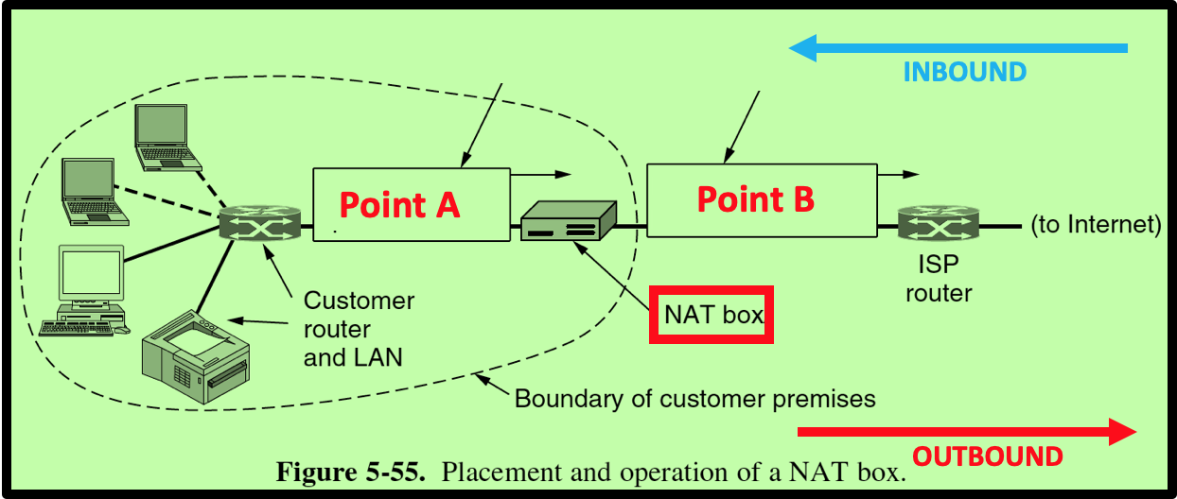

1. **(5 points)** Suppose you want to deploy NAT at your home. Do you need to contact some Internet organization/authority or your Internet provider to get assigned some range of IP addresses to use on your **internal** network?

On an internal network you should not have to contact any provider to deploy NAT. The purpose of NAT is that these IP addresses are already deployed on a given router. This addresses are a standard predefined private IP that are meant for home devices, or devices that then translate onto the global address from a service provider.

1. **(5 points)** What is (are) the range(s) of IP addresses you could use on your internal network?

10.0.0.0 to 10.255.255.255

172.16.0.0 to 172.31.255.255

192.168.0.0 to 192.168.255.255

These ranges are designated for private use and cannot be routed on the public Internet, making them ideal for NAT.

1. **(5 points)** Does your wireless network at home use NAT? What is the IP address of your desktop, laptop, or any device you use to access Internet from home?

Yes my wireless network at home also uses NAT. The IP address of a given wireless device would be assigned by the DHCP service on my router. These wireless ranges could be picked from the previous listed ranged for the question before.

6) **(5 points)** Suppose that you want to use NAT on your network at home. What is the smallest number of external (Internet) IP addresses you would need to acquire from your Internet provider?

The smallest number of external IP addresses you need to acquire from your internet provider is one, as NAT can manage multiple internal devices using this single public IP address.

**NAT Operations**

First let us define a **flow**: *two packets belong to the same TCP (or UDP)* ***flow*** *if both packets carry a TCP segment (or a UDP datagram) that have the* ***same*** *source IP address, destination IP address, source port number, and destination port number.*

For all the following questions, we assume that the NAT box has the following available ports for translation for TCP and UDP. When the NAT box needs to translate a packet for a **new** flow, it will pick the next available port number from the table below. We assume that the next available port number for TCP (resp., UDP) is at Index 1. If the port number at Index 1 is already used, the next available will be the one at Index 2 and so on. **We assume that the NAT was just turned on**. Therefore, the next available port # for translation of a TCP (resp. UDP) flow is 7008 (resp. 9002).

|  |  |  |
| --- | --- | --- |
| Index | TCP | UDP |
| 1 | 7008 | 9002 |
| 2 | 6170 | 2750 |
| 3 | 1463 | 1070 |
| 4 | 1078 | 2553 |

As seen on Figure 5-55, a customer sets up a network with multiple machines. However, the Internet provider assigned only one IP address to the customer: this IP address is 131.63.192.20.

Consider a machine M on the customer's network "behind" a NAT box, i.e. on the premises of the customer (see Figure 5-55 above). The IP address of Machine M is 192.66.168.32. A TCP client socket is established at Port # 10100 to send an http query ***Q*** to the server at IP address 64.253.150.188.

1. **(10 points)** Consider Packet P1 carrying the http request ***Q.*** P1 **leaves** Machine M and reaches Point A (see Figure 5-55). Fill in the array below with the source IP address, destination IP address, source port number, destination port number of Packet P1 when it is at Point A. Tell whether this packet P1 carries a TCP segment or a UDP datagram.

This packet will be carrying a TCP segment, as it is trying to establish a HTTP connection, which would be a TCP connection.

|  |  |  |  |  |
| --- | --- | --- | --- | --- |
| TCP or UDP? | IP Source | IP Destination | Source Port # | Dest. Port # |
| TCP | 192.66.168.32 | 64.253.150.188 | 10100 | 80 |

2) **(10 points)** When the NAT box receives Packet P1, it translates it and outputs on Point B (see Figure 5-55) a translated packet. Fill in the array below with the source IP address, destination IP address, source port number, destination port number of the **translated** Packet P1. Highlight the information that will change (by the translation) and explain why.

|  |  |  |  |  |
| --- | --- | --- | --- | --- |
| TCP or UDP? | IP Source | IP Destination | Source Port # | Dest. Port # |
| TCP | 131.63.192.20 | 64.253.150.188 | 7008 | 80 |

The source IP address changes to allow the packet to be routable on the internet, as private IP addresses are not. The source port number is changed to a unique value to differentiate this particular session from others that the NAT box may be translating, thus enabling the NAT box to correctly direct the return packets to the originating host's IP and port.

3) **(10 points)** When Packet P1 reaches the server, the server will respond with a packet **P2**. Fill in the array below with the source IP address, destination IP address, source port number, destination port number of the Packet **P2**.

|  |  |  |  |  |
| --- | --- | --- | --- | --- |
| TCP or UDP? | IP Source | IP Destination | Source Port # | Dest. Port # |
| TCP | 64.253.150.188 | 131.63.192.20 | 80 | 7008 |

4) **(10 points)** When the inbound packet P2 reaches the NAT box, it will be translated. Fill in the array below with the source IP address, destination IP address, source port number, destination port number of the **translated** Packet P2 (Point A).

|  |  |  |  |  |
| --- | --- | --- | --- | --- |
| TCP or UDP? | IP Source | IP Destination | Source Port # | Dest. Port # |
| TCP | 64.253.150.188 | 192.66.168.32 | 80 | 10100 |

5) **(10 points)** Suppose now that the same machine M (IP address :192.66.168.32) makes a DNS request to the server at IP address 129.57.154.04. The DNS client is bound to Port # 10020. The DNS request will be carried by Packet P3. Fill in the array below with the source IP address, destination IP address, source port number, destination port number of Packet P3 (Point A).

|  |  |  |  |  |
| --- | --- | --- | --- | --- |
| TCP or UDP? | IP Source | IP Destination | Source Port # | Dest. Port # |
| UDP | 192.66.168.32 | 129.57.154.04 | 10020 | 53 |

6) **(10 points)** When the NAT box receives Packet P3, it translates it and outputs on Point B (see Figure 5-55) a translated packet. Fill in the array below with the source IP address, destination IP address, source port number, destination port number of the **translated** Packet P3. Highlight the information that will change (by the translation) and explain why.

|  |  |  |  |  |
| --- | --- | --- | --- | --- |
| TCP or UDP? | IP Source | IP Destination | Source Port # | Dest. Port # |
| UDP | 131.63.192.20 | 129.57.154.04 | 9002 | 53 |

The information that changes due to the translation by the NAT box is the source IP address and the source port number. The source IP address is changed to the public IP address to ensure the packet can traverse the Internet. The source port number is changed to a unique value from the NAT's port mapping table so that responses from the DNS server can be translated back to the correct internal IP address and port number, allowing the NAT to maintain the correct flow of communication.

**What you need to turn in**:

* Electronic copy of this file (including your answers) (standalone). Submit the file as a Microsoft Word or PDF file.
* Recall that answers must be well written, documented, justified, and presented to get full credit.
* How this assignment will be graded:
* A right answer will get full credit when:
* It is right (worth 25%)
* It is right AND neatly presented making it easy and pleasant to read. (worth 15%)
* There is an obvious and clear link between 1) the information provided in the exercise and in class and 2) the final answer. A clear link is built by properly writing, justifying, and documenting an answer (worth 60%).
* Calculation mistakes will be minimally penalized (2 to 5% of full credit) while errors on units will be more heavily penalized.
* You are welcome/encouraged to discuss exercises with other students or the instructor. But, ultimately, personal writing is expected.